GUIDE TO USING THE LEXCO TOTAL CONNECT PORTAL

LEXCO TOTAL CONNECT
Use the Lexco Total Connect Portal to remotely connect to your home security system.

Total Connect features include:
- Remote Arming/Disarming of security system
- Watch real-time video from your home of office
- Save energy by remotely controlling connected thermostats and lights

- Go to the Lexco Security Website Resources Page http://www.lexcosecurity.com/#!lexco-resources/c1fsl
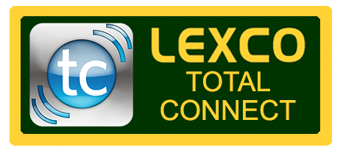
- Click on the Lexco Total Connect button

- Enter Username. This was created for you during the initial setup of your Total Connect System.

- Enter Password. This was also created for you during the initial setup of your Total Connect System.

- Scroll to the Security section and select disarm, arm away, or arm stay and enter the 4 digit user code for your alarm system.

- Scroll to the Video section to view live video from your security cameras

- Remember to Log Out when you are finished using the portal.

www.lexcosecurity.com (203) 367-4930

