GUIDE TO USING THE LEXCO CENTRAL STATION PORTAL

LEXCO CENTRAL STATION
Use the Lexco Central Station to review emergency contact information and recent alarm history.

- Go to the Lexco Security Website Resources Page http://www.lexcosecurity.com/#!lexco-resources/c1fsl
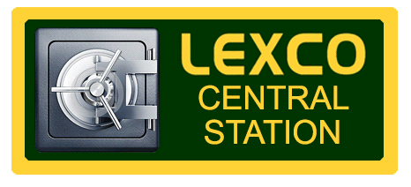
- Click on the Lexco Central Station button.

- Enter Username/Account ID. This is your seven digit account number that can be found on your alarm contract or on a label directly on your alarm panel.

- Enter Password. The password is your secret password that is used to cancel an alarm with the central station. This password can also be found on your alarm contract.

- To review emergency contact information, select Emergency Contacts on the left menu.

- To review recent alarm history, select Recent History on the left menu.

- Remember to Sign Out when you are finished using the portal.

www.lexcosecurity.com (203) 367-4930

